Our Top Recruiters:
Sr. No. | Company Name | Logo
1 | Advantmed | 
2 | Aquity Solutions | 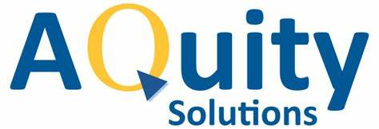
3 | Astra Zeneca | 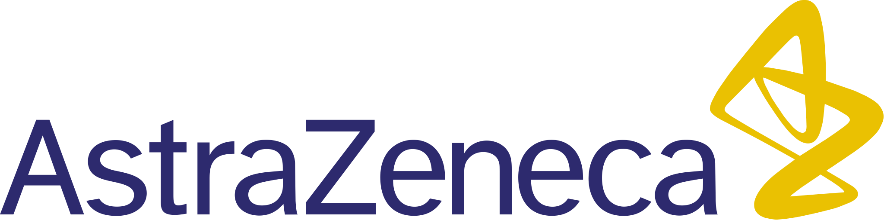
4 | Fourrts India Laboratories Pvt. Ltd | 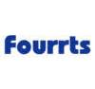
5 | GeBBS Healthcare Solutions. | 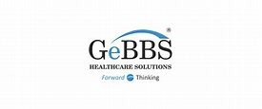
6 | Lupin | 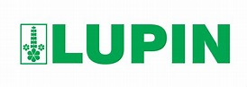
7 | Piramal | 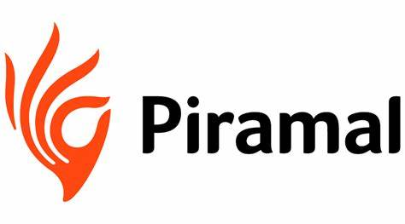
8 | Reliance Foundation | 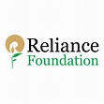
9 | Serum Institute of India | 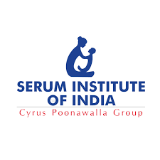
10 | Novartis | 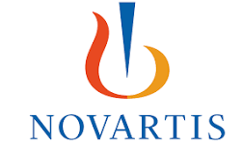
11 | TCS | 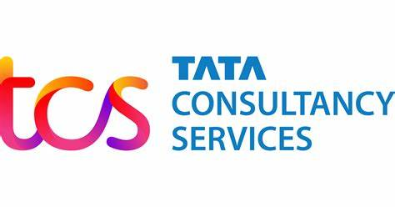
12 | Shilpa Medicare Ltd. | 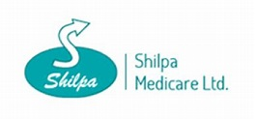
13 | Nutrigold Healthtech LLP | 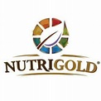
14 | Mankind Pharma | 
15 | Emcure Pharmaceuticals | 
16 | Episource | 